**Graph Potter Python Project**

**END TERM REPORT**

***by***

**Lalit Kumar, Sanjay Chaudhary, Dipesh Saxena**

Section: K19PG

Roll Numbers: 43,59,47



**Department of Intelligent Systems,**

**School of Computer Science Engineering,**

**Lovely Professional University, Jalandhar**

November, 2020

**Student Declaration**

This is to declare that this report has been written by us. No part of the report is copied from other sources. All information included from other sources have been duly acknowledged. We aver that if any part of the report is found to be copied, we are shall take full responsibility for it.

Signature:

Name: Lalit kumar; Dipesh Saxena; Sanjay Chaudhary

Roll Number:43, 47,59

Place: Home

Date: 30/10/2020

**TABLE OF CONTENTS**

**TITLE: Graph Plotter PAGENO.**

|  |  |  |
| --- | --- | --- |
| **1. Background and objectives of project assigned ................** | | **1** |
|  |
|  |
| **2. Histogram………………………………………………….** | | **3** |
| **3. Column chart………….......................................................** | | 4 |
| **4.Box plot chart………...........................................................** | | **5** |
| **5.Pie chart .................................................................................** | | **6** |
| **6.Scatter chart ...........................................................................**  **7.Description of Work Division in terms of Roles among Students…………………………………...**  **8.** **Technologies and Framework………………………………** | | **7**  **8**  **9** |
|  | |  |
| **9.**  **Analysis achieved in project……………………**  **10. Output Pictures……………………………** | | **10**  **11** |

BONAFIDE CERTIFICATE

Certified that this project report “**Graph plotter**” is the bonafide work of “**Lalit Kumar, Sanjay Chaudhary, Dipesh Saxena**” who carried out the project work under my supervision.

`

<<Signature>>

<< Dr Dhanpratap Singh >>

<<Assistant Professor>>

<<ID: **25706**>>

<<Department of Intelligent Systems>>

<<School of Computer Science & Engineering>>

Background and Objectives of the project assigned

* Our main objective of this project is to knowing about different types of programs how they are drawn and how we are able to implement and what are different algorithms that are used while writing programs in python language what are different libraries that are used in python to display graphs.
* What are different ways to organize a raw data to graphical form and how different data sets can be compared which type of graphs helps to identify and organized different types of data.
* Teamwork

Knowledge

Coordination

Python libraries

Python basic graphs

Are some of important terminologies that were objectified in our project

**Types of Graphs**

* Histogram
* Column chart
* Box plot chart
* Pie chart
* Scatter chart

**Histogram**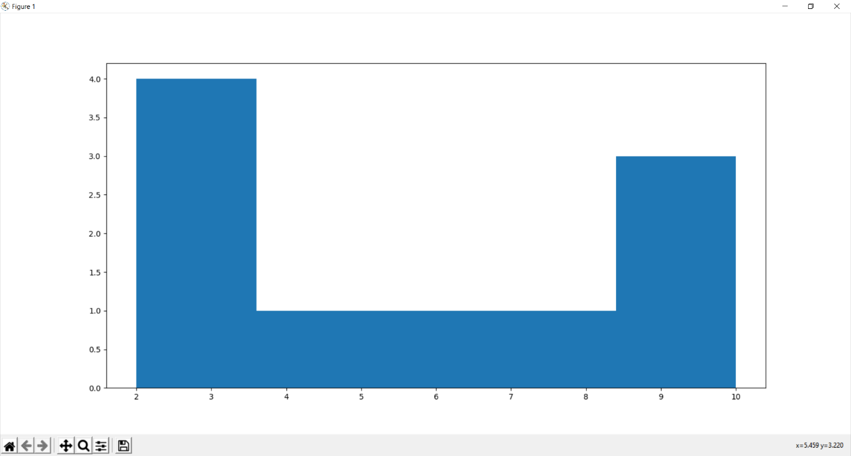

* A histogram is a bar graph that shows data in intervals
* It has adjacent bars over the intervals
* In this graph values are measured on arithmetic scale on x axis and bars are of equal width
* It corresponds to equal class intervals
* on y axis it corresponds to frequency of class
* We can use histogram for representation of ranges of data and to plot graphs for continuous data

**Column chart**

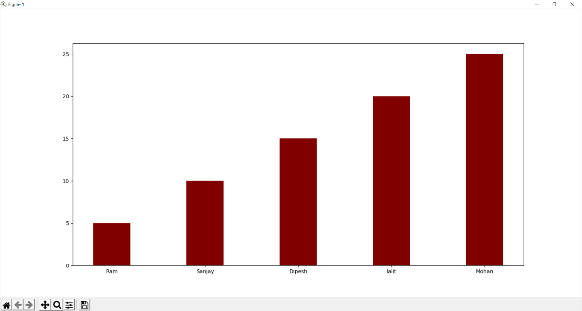

* It is a chart which displays vertical bars across chart horizontally with values being displayed on left side of chart
* These are often used to create spreadsheet, to display sales, stock prices
* In this type of graphs thickness of bars is of same width
* In this type of graphs comparison b/w two values becomes very easy
* This type of graphs is effective at showing situation at a time or at an instance

**Box plot chart**

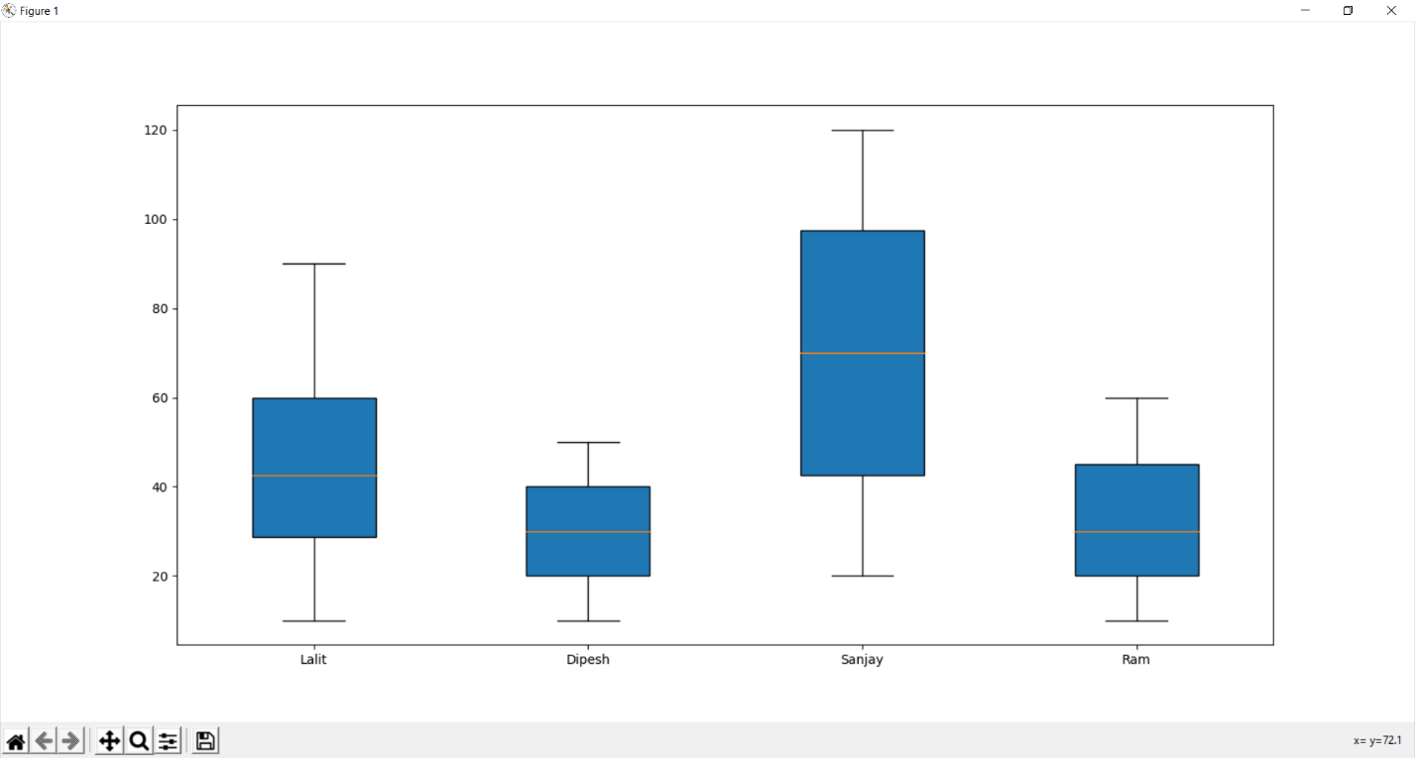

* This type of graphs is used for measuring dispersion of data
* For plotting such graphs, we calculate a) minimum b) first quartile Q1 c) median Q2 d) Q3 3rd quartile e) maximum
* First quartile is known as median of lower half of datasheet
* Third quartile is known as upper half of datasheet
* This type of graph is constructed in two parts lower part is minimum and upper is maximum

**Pie chart**

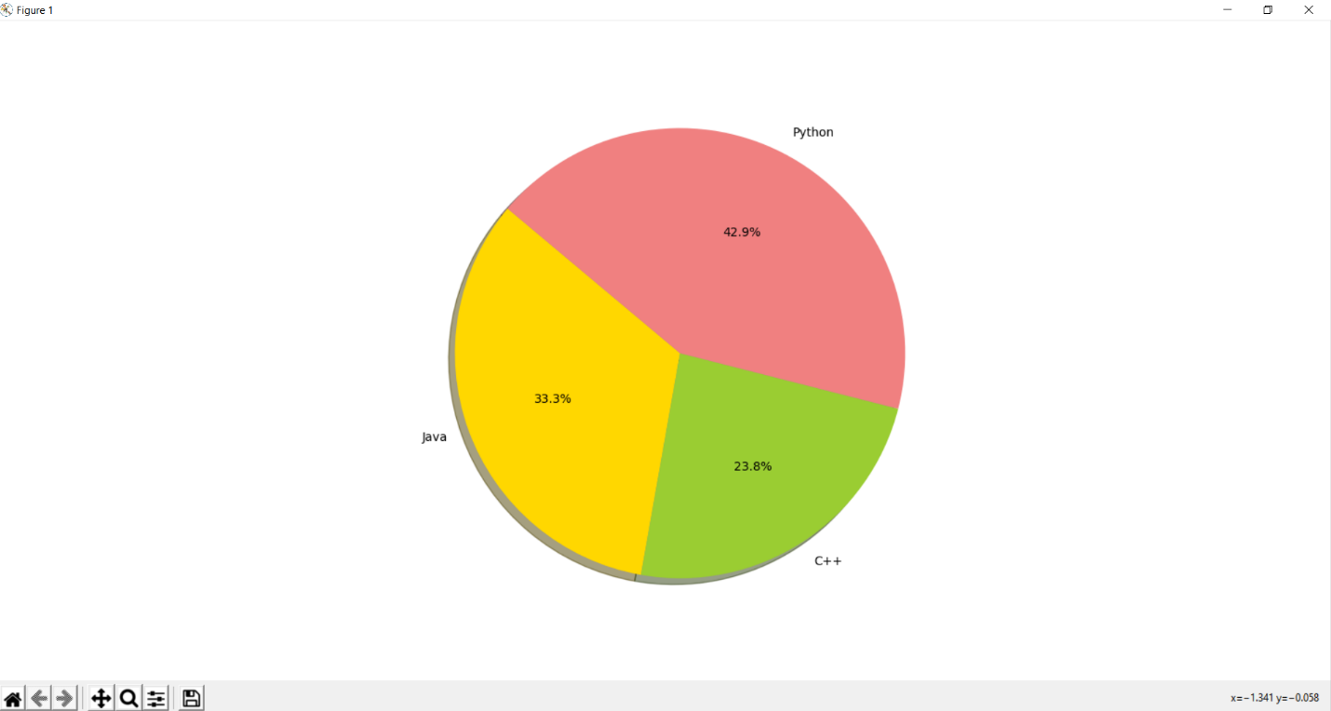

* This type if graph is also called circle chart
* In such graphs arc length of each slice or sector is proportional to quantity it represents
* Total circle has value equal to 100% it is divided in percentage area as per its values
* Disadvantage of such graphs is that they are not very good at comparing size of angles because there is no scale reading accurate values becomes difficult
* Worse about such charts is these covers more space as well

**Scatter chart**

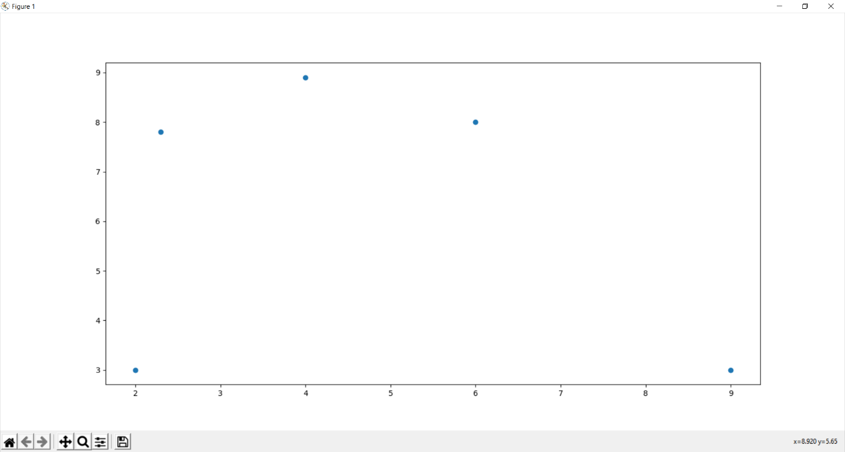

* This type of graphs is representation for two different values by plotting dots and observing relationships between variables
* This type of graphs makes easier to compare two or more different sets of data
* Scatter point is location of point whose x-y are coordinates that relate its value
* Relation b/w scatter points known as correlation
* Correlation is of two types positive and negative it is located as below and above x axis

Description of Work Division in terms of Roles among Students

In this project we have designed a graph plotter which helps us to representing our raw data unorganized data to show it in an organized and pictorial graphical way through which we are able to identify and compare previous record as well

We all three of us has worked equally we dived our work in three of our team mate one of us wrote programs in which we have used a python library matplotlib which helps us in designing graphs on our computer machine and other teammate helped in identifying error in those programs and correcting and organizing graphs and inputting different variable and one of us designed main file that show all graphs as a menu in which we can proceed systematically and all three of us gave equal participation in writing report all telling all about graphs and python programs

Types of graphs we have shown in menu are box plot, column chart, histogram, pie chart and scatter plot graph which helps us in showing all our data in organized and well comparable way

Technologies and Framework

Technologies we have used so far is written program in python language and an IDE to compile and execute programs and displaying our data in graphically but now a days in graphs have become so fast that we have designed so many algorithms that represent real time graphs by analyzing raw data and even we are so fast in this era with the help of increasing and decreasing graphs we are able to predict next outcomes and possibilities as well so all we need to have is a computer and an algorithm to read data and representing it graphically is so easy

* It helps in graph technology trend from emerging to dominance
* Graph databases
* Graph analytics
* Personalization
* Application of real time cricket and stock market type of things

Analysis achieved in project

We came to importance of graphs and implementation of python to display graphs on computer and what algorithms are used to show graphs. Graphs are a common method to visually illustrate relationships in the data. **Graphs are beneficial because they summarize and display information in a manner that is easy for most people to comprehend** The purpose of a graph is to present data that are too numerous or complicated to be described adequately in the text and in less space.  Graphs are used in many academic disciplines, including math, hard sciences and social sciences. Do not, however, use graphs for small amounts of data that could be conveyed succinctly in a sentence They make appearances in corporate settings, serving as useful tools to convey financial information and facilitate data analysis. Concluding all graphs plotter is very helpful program concept that makes a lot of things easy and comparable and represents data graphically

Thank you, my teammates and respected sir, under you this supervision we could complete thanks for golden opportunity

**Output Pictures**

